

**Question/Answer Booklet**

**Name:**

**PHYSICAL EDUCATION STUDIES**

**Yr 11 ATAR 2021**

**Semester 1: Class Test 2**

**Time allowed for this paper**

Working time for paper: 45 minutes

**Material required/recommended for this paper**

***To be provided by the supervisor***

This Question/Answer Booklet

|  |  |  |  |
| --- | --- | --- | --- |
| **Contents:**  Functional Anatomy | Multiple choice  Short answers  Extended question | 10 marks  30 marks  10 marks  **Total marks** | **/50** |

**Multiple Choice (10 marks)**

1. Which of the following is not a characteristic of capillaries?

(a) Exchange carbon dioxide and oxygen.

(b) Have thin walls.

(c) Are microscopic.

(d) Have strong elastic walls.

2. The insertion point for the triceps muscle group is located on the:

(a) Ulna.

(b) Radius.

(c) Humerus.

(d) Scapula.

3. Extension of the knee joint involves:

(a) The hamstrings and gastrocnemius coming closer together.

(b) The hamstrings and gastrocnemius moving further apart.

(c) The tibialis anterior and gastrocnemius coming closer together.

(d) The tibialis anterior and gastrocnemius moving further apart.

4. Which of the following muscle groups are antagonistic pairs?

(a) Hamstrings, soleus.

(b) Pectorals, latissimus dorsi.

(c) Trapezius, biceps.

(d) Tibialis posterior, soleus.

5. Identify the joint movement performed by a swimmer’s shoulders during a backstroke race:

(a) Adduction.

(b) Flexion.

(c) Extension.

(d) Circumduction.

6. In which of the following actions would the quadriceps muscles be considered the agonist

(a) pointing your toe.

(b) Bending of the knee in breaststroke.

(c) kicking a soccer ball.

(d) catching a basketball.

Question 7 and 8 refer to the following table.

|  |  |  |  |
| --- | --- | --- | --- |
| **Muscle Fibre Type** | **Contraction Speed** | **Fatigue Rate** | **Force Production** |
| Red Fibres | Low | A | B |
| White Fibres | High | C | D |

7. The correct description at A and C would be

(a) A = high, C = low

(b) A = low, C = high

(c) A = low, C = low

(d) A = high, C = high

8. The correct description at B and D would be

(a) B = high, D = low

(b) B = low, D = high

(c) B = low, D = low

(d) B = high, D = high

9. White blood cells are responsible for

(a) fighting infection

(b) transporting nutrients

(c) blood clotting

(d) transporting nutrients

10. Gaseous exchange occurs between the capillaries and which respiratory system component?

(a) diaphragm

(b) alveoli

(c) pharynx

(d) bronchiole

**Short Answer (30 marks)**

**Question 11 (3 marks)**

**A**

**C**

**B**

Identify the bones A through to C on the diagram below.

**B**

**A**

|  |  |  |
| --- | --- | --- |
| **A.** | **B.** | **C.** |

**Question 12 (4 marks)**

**A B**

In reference to the picture above, identify:

|  |  |
| --- | --- |
| 1. Joint movement (from A to B) |  |
| 1. Agonist |  |
| 1. Origin (of agonist) |  |
| 1. Insertion (of agonist) |  |

**Question 13 (4 marks)**

The body consists of three types of blood vessels: arteries, veins and capillaries. Compare and contrast **two (2)** characteristics of veins and arteries.

**Question 14 (5 marks)**

Slow-twitch muscle fibres are also known as Type I muscle fibres. Briefly describe **three (3)** characteristics of slow-twitch fibres other than colour that differ from fast-twitch muscle fibres. Identify one activity suited to slow-twitch muscle fibres providing a reason for your answer.

___________________________________________

___________________________________________

**Question 15 (4 marks)**

One of the major functions of the circulatory system is to circulate blood to the body. Describe **two (2)** other functions.

**Question 16 (6 marks)**

Identify the **muscles** A through to F on the diagram below.

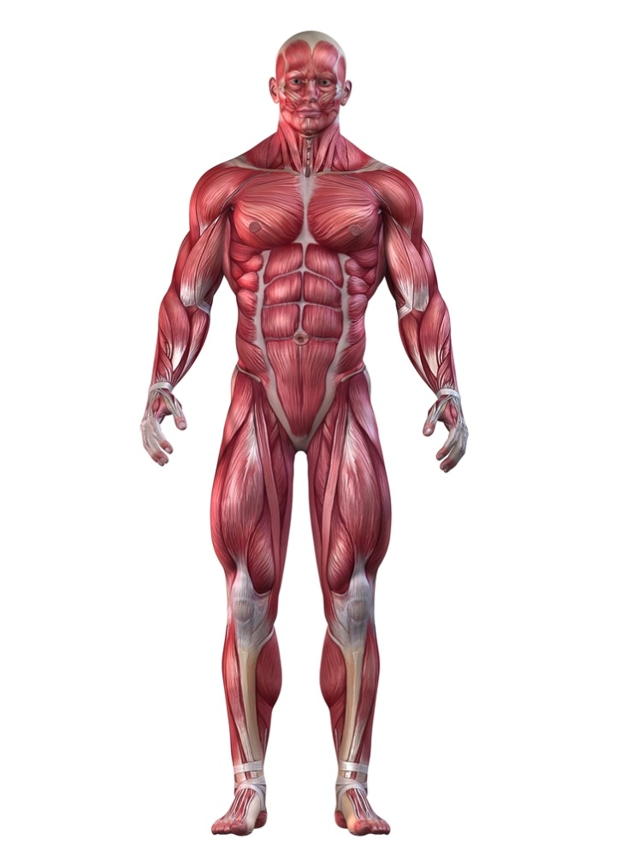

**A**

**B**

**C**

**D**

**E**

**F**

|  |  |  |
| --- | --- | --- |
| **A.** | **B.** | **C.** |
| **D.** | **E.** | **F.** |

**Question 17 (4 marks)**

Complete the table below, naming and defining the characteristics of skeletal muscle.

|  |  |
| --- | --- |
| **Characteristic** | **Definition** |
|  | *The ability of a muscle to contract in response to a signal or nerve impulse sent from the Central Nervous System* |
| *Contractibility* |  |
|  | *The ability of a muscle to stretch beyond its regular resting length* |
| *Elasticity* |  |

**Extended Answer (10 marks)**

**Question 18 (10 marks)**

From the point of inhalation, describe the mechanics of breathing, including pressure change and flow of oxygen through the cardiorespiratory system to supply oxygen to the working muscle/s.

**End of TEST**